Forward Together in Hope Update: August 2015
Exploring the Way
- Clergy and Lay representatives received a range of materials at Pentecost including:
- Exploring the Way Booklet (The key document to read first)
- Parish Questionnaire
- Parish Questionnaire Supplement
- PowerPoint Presentation
- One-page handout for copying to all parishioners
- Spirituality resources including prayer for vocations
- Disk with all of these resources plus additional items
- Data Pack - hardcopy and electronic versions.

- All materials (except individual parish data packs) are available from the website: www.hope.rcdhn.org.uk and electronic versions of these documents have been sent to each Catholic school.

- Parishes are starting to run meetings to feed into the self-evaluation and questionnaire completion. It is expected that the process will involve a large number of people from parishes and schools inputting their thoughts and ideas.

- Parish Questionnaires need to be completed on-line by Advent 2015. Details of the process for doing this will be made available to parishes in the Autumn.

NEW Individual Questionnaire now online – Please spread the word
- A short questionnaire that provides the opportunity for anyone to offer comments about the present and the future of the Catholic Church in the Diocese is now available online. We are particularly keen to get responses from those Catholics who do not attend church regularly in order to learn as much as we can from their perspectives. Please publicise the link https://forwardtogether.onlinesurveys.ac.uk/hope as widely as you can – for example through newsletters, websites, schools, social media etc.

Feedback from July Networking Meeting
- Around 90 parish representatives attended a networking meeting on Saturday 11th July at St Robert’s in Fenham. Feedback from that meeting – including information about the work taking place in parishes across the Diocese and responses to questions posed at the session - is available on the website.

Involving Young People
- A number of parishes are thinking about how to involve young people in the Forward Together in Hope review process so we asked Mary Hughes from YMT to give us some ideas. These are set out in a short annex at the end of this Update.
Deanery Meetings
- Meetings are taking place in each of the 18 Deaneries between early September and mid- October and will bring together clergy, Forward Together in Hope lay representatives and others from each parish as well as representatives of Catholic schools in the Deanery to:
- Hear a short update on the Exploring the Way stage of the process
- Provide the opportunity for representatives to ask questions, make observations or clarify issues that are arising as a result of the self-evaluation process taking place in parishes
- Share the approaches and good practice taking place in different communities.
The dates, times and venues are shown below. It is important to let us know if you wish to attend (hope@diocesehn.org.uk).

Number and Name of Deanery | Date and Time | Venue
- St Mary and St Margaret Clitherow | Thursday 8th October at 7pm | Church of St John Vianney, Hillhead Parkway, Chapel House Estate, Newcastle upon Tyne NE5 1DP
- St Andrew and St Anthony | Thursday 8th October at 7pm | St Aidan’s, Coach Lane, Benton, Newcastle upon Tyne NE12 8AD
- City Centre Deanery | Wednesday 30th September at 6:30pm | Cathedral Church of St Mary, Clayton Street West, Newcastle upon Tyne,  NE1 5HH
- St Paulinus and St Wilfrid | Wednesday 14th October at 7pm | St Aidans, Station Road, Ashington, NE63 8AD
- St John of Beverley | Monday 28th September at 7pm | St Mary’s, Hencotes, Hexham, Northumberland NE46 2EB
- St Oswin | Wednesday 7th October at 6pm | St Cuthbert’s Church Hall, Albion Road, North Shields, NE29 0JB
- St Thomas Aquinas | Wednesday 30th September at 6:30 pm | Immaculate Heart Church, Malvern Gardens, Lobley Hill, Gateshead, Tyne & Wear, NE11 9LL
- St Joseph and St Robert of Newminster | Thursday 1st October at 7pm | St Anne’s Parish Hall, Rokeby View, Harlow Green, Gateshead, NE9
- St Aidan and St Gregory | Thursday 17th September at 7pm | St Bede, Chapel Road, Jarrow, NE32 3LX
- St Bede | Wednesday 7th October at 6pm | St Joseph’s Parish Centre, Paxton Terrace, Millfield, Sunderland SR4 6HP
- St Chad | Tuesday 29th September at 7pm | St Joseph’s School, Front Street, Stanley, Co Durham, DH9 0NP
- St Cuthbert | Tuesday 6th October at 7pm | Ushaw College , Woodland Road, Durham  DH7 9RH
- St Michael | Tuesday 6th October at 7pm | St John Boste, Crighton, Oxclose, Washington, NE38
- St Patrick | Thursday 10th September at 7pm | St Joseph’s, Coast Road, Blackhall, Hartlepool TS27 4HW
- St William | To be confirmed | To be confirmed
- St Augustine | Wednesday 16th September at 6:30pm | St Anne’s Parish Hall, 43 Welbeck Ave, Darlington, DL1 2DR
- St Hilda | Saturday 26th September at 10am | English Martyrs 6th Form College, Catcote Road, Hartlepool, TS25 4HA
- St Peter | Thursday 15th October at 6:30pm | St Patricks Parish Hall, Glenfield Road, Fairfield, Stockton on Tees, TS19 7PL

New Resources
- A Braille version of the Forward Together in Hope prayer will be available very shortly – please contact us (hope@diocesehn.org.uk) if you need copies. This item will be provided on an ‘on request’ basis.

- An A3 Forward Together in Hope poster is being produced for general use in parishes and will be available by the middle of August. It includes the Forward Together in Hope logo and graphics but is left largely blank for writing or overprinting with your own information. We envisage them being used to advertise meetings, provide local information on noticeboards etc. The posters will be made available in due course to all parishes but if you need any in the next few weeks, get in touch and we’ll send some when they are available.

- A second Forward Together in Hope DVD is currently in production and we aim to have this available in early September. It seeks to respond to some of the issues and questions that are being highlighted as we journey through Forward Together in Hope.

Share your ideas
Some really interesting and innovative ideas are emerging from parishes about how they are implementing Forward Together in Hope. Please send us details of any particular approaches you are using – and we will make these available to others across the Diocese.

We have collated some of the ideas that came out of the parish representatives’ networking session on 11th July and these, with other suggestions, will be available shortly in a new Good Practice area of the website. In the meantime we are featuring here a couple of examples that that have come to our attention recently.
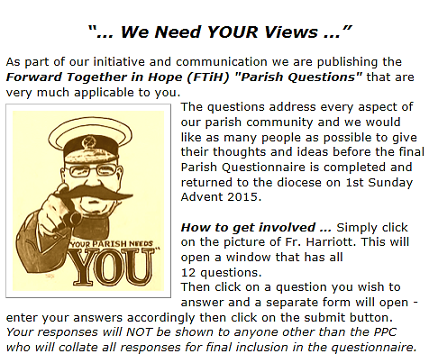
- On-line collation of parishioners’ views
Jerry Laidler has told us about the approach that they are taking in Annitsford to enable parishioners to input on-line responses to the reflective questions in Part B of the questionnaire. They have set up a facility on the Parish Website (https://sites.google.com/site/stjohnsannitsford/home) that allows parishioners to click on each of the 12 key questions and their responses are collated to feed into the process. The approach uses ‘Google Forms’ and Jerry is very happy to assist other parishes in setting up a similar arrangement. He can be contacted on jerrylaidler@sky.com

- New Frontals at St Paul’s in Cramlington
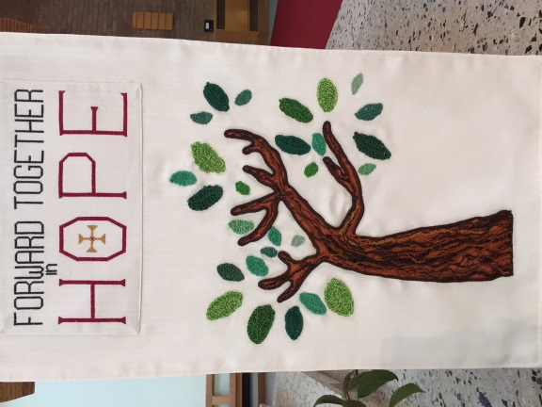
Deacon Rob Wareing has sent us photographs of new Frontals for the Altar and lectern that have been crafted by parishioners at St Paul’s Church in Cramlington following the Forward Together in Hope theme.
Getting involved
Forward Together in Hope will require a lot of activity at local level. Please consider getting involved in this – speak with your lay contact or Parish Priest. Also, the Forward Together in Hope team at the Diocese is always on the look-out for skilled volunteers who can support and contribute to this work in various ways.

Finding out more
For the latest information about Forward Together in Hope and for access to the range of resources, please visit www.hope.rcdhn.org.uk

To contact one of the Forward Together in Hope team, (Jim O’Keefe, Tony Sacco and Nancy Gash) e-mail: hope@diocesehn.org.uk or phone 0191 243 3304.

And finally…
…an irresistible photo opportunity during a recent visit to Liverpool!
Tony Sacco – August 2015
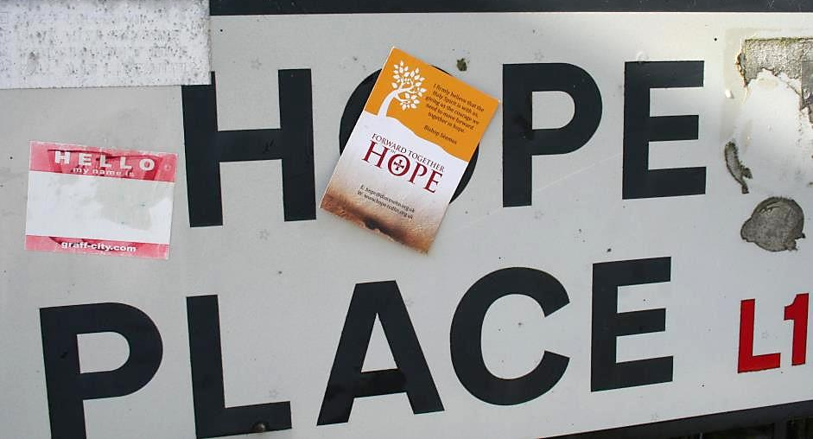
Young People and Forward Together in Hope
Tony Sacco – August 2015
A number of parishes are thinking about how to involve young people in the Forward Together in Hope review process so we asked Mary Hughes from YMT to give us some ideas. Her thoughts are below:
There are two sections in the Forward Together in Hope Parish Questionnaire about young people (Section 10 in Part A and Section 10 in Part B) and the best people to respond to these are the young people themselves. It may be that adults in the parish feel they can answer the factual questions in Part A. However, it will be a challenging and mutually enriching experience to gain a young person’s perspective on these questions. The reflective questions in Part B certainly cannot be answered in the best way without listening to young people. So how do we involve young people in this process?

- Personal invitation is the best starting point to gather young people. There may be a small number of young people who attend Mass. Begin there and ask them to meet with you and look at the questionnaire.

- Ask families to help you by involving their children or grandchildren who may not be coming to church, and who may be at university etc. Give the families a pack to pass on explaining the process and inviting them to respond especially to the reflective questions. The pack will need a clear introductory message and copies of the questions.

- Invite young people from the parish who have recently been Confirmed.

- Most of our young people are in school. Work with the local secondary school to invite young people from the parish to meet with some parishioners either in school or in the parish.

- Find out from your school or from YMT if you have Youth Council members in your parish. Invite them to contribute to the process.

- If there are young people of sixth form age who are enrolling this September in the Pope John Paul II Award scheme, invite them to be involved in the process as part of their parish commitment.

- If your parish or school has a group of Lourdes Youth, invite them personally to meet and discuss the questions.

- Encourage and facilitate young people to take up a leadership role in this process when there is a larger meeting of parishioners and to look at the review more widely.

Mary Hughes is happy to be contacted on 01207 592244 or mary.hughes@ymt.org
The Forward Together in Hope Team is keen to identify and share what
parishes are doing to engage young people in Forward Together in Hope.
Please tell us about your activities – e-mail hope@diocesehn.org.uk
or phone us on 0191 2433304.

